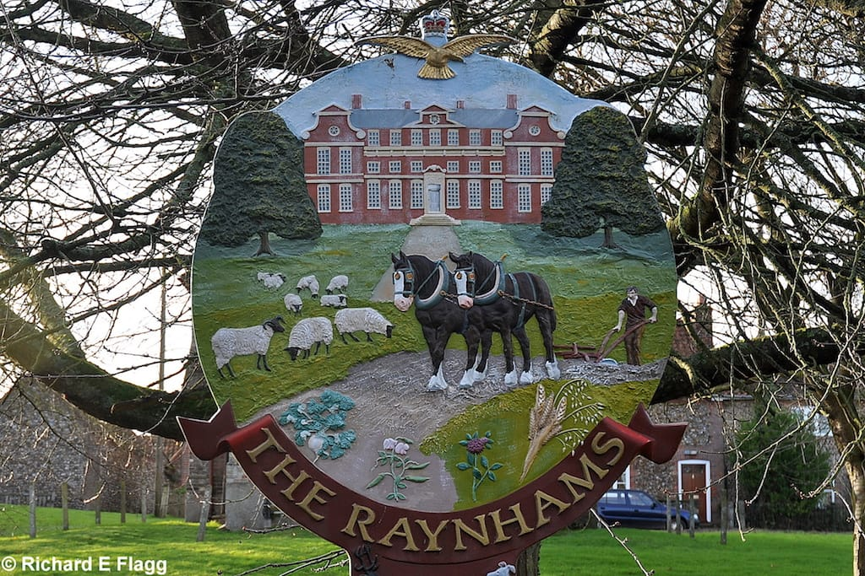

Raynham Parish Council

Health and Safety Policy

**Purpose of the Policy**

It is noted that there is no requirement for a Council which employs less than 5 people to have a policy, but the council considers it is best practise to detail its responsibilities under Health & Safety legislation. The council is committed to providing a safe working environment for its staff and a safe environment for the users of its facilities. The policy helps explain how the council will meet its duties under this legislation.

**Responsibilities for health and safety**

The council is ultimately responsibility for health and safety, which will be managed by its officer, the Parish Clerk. The responsibilities of the Clerk are detailed in this policy as well as in the job description.

**Arrangements for health and safety**

1. The Council’s Insurers

The Clerk arranges the insurance of the council, which will be reviewed every third year. The insurer is currently: Contacts details: BHIB Ltd - Tel 0330 013 0036 Claims: None

The council must have Employer Insurance (£10 million); Public Liability (£10 million); Fidelity Guarantee (at least to the level of the balance at year end); asset insurance;

1. Risk Assessments

The council must undertake risk assessments for all of its activities. These are detailed as an annexe to this policy. It is the duty of the Clerk to write these risk assessments and discuss with the people involved in the activity to minimise risk to everyone.

Risk Assessments : Play Area, Bus Shelters. Risk assessments will be regularly reviewed.

1. Contractors

The council will use contractors who hold the required public liability insurance and will request a copy of the certificate of insurance. The level of public liability required will depend on the type of work being undertaken and where it is being undertaken. If unsure the Clerk should discuss the level of public liability insurance with the council’s insurer. Risk assessments should be undertaken by contractors for all works and the council should have a copy of this.

Areas where work is undertaken by contractors are Grass Cutting & General Maintenance.

1. Council’s Own Staff

The council may employ its own staff or volunteers to undertake tasks provided those tasks have been risk assessed and the person doing them has been provided with appropriate well-maintained equipment as well as safety equipment. Note that any chain saw work will require a suitably qualified person to undertake.

1. Play Areas

The Clerk will arrange regular fortnightly play equipment inspections which will be logged. The clerk will arrange annual professional inspections. All repair works identified will be arranged by the Clerk. The regular inspections will make a cursory inspection of equipment, notices, safety surfacing and also for litter. The Play Area for which the council has responsibility is on The Street, West Raynham.

1. Council Property

The Clerk will arrange annual inspections of council property such as benches, bins, noticeboards and bus shelters. Repair work will be arranged by the Clerk. The council will ensure that its lighting contractor includes an annual inspection of lighting columns.

Any equipment owned by the council such as mowers will be annually serviced.

1. Other Open Space Areas

The Council will make an inspection of its other open space areas. Areas where dangers might be seen to be more acute will be inspected monthly. The other open space areas the council has responsibility for are Cherry Tree Green, Hollow Lane Footpath, Village Hall Green.

1. Trees

Trees in the ownership of the council or those trees adjacent to public space areas will be inspected annually – most appropriate time is considered to be the end of the Summer.

The areas identified for tree inspection are; Play Area.

**Safety for its employees, volunteers, councillors and visitors**

The council will ensure that its employees are provided with a safe working environment. This will be supported by a Lone Workers Policy. The council will ensure that councillors, volunteers, employees and visitors who use the public facilities used by the Parish Council are provided with a safe environment and measures have been taken to reduce risk by regular inspections of these premises. All these facilities, wherever possible, should provide disability access and facilities.

The council meetings are generally held bi-monthly

**Budget**

The council will ensure that it will maintain a budget which is adequate to maintain its assets as well as provide training to staff, volunteers and councillors. The clerk as RFO will ensure that budgetary provision is adequate and a reserve fund is held for long term maintenance or replacement of council assets.

Give details of the practical arrangements you have in place, showing how you will achieve your health and safety policy aims. This could include, for example, doing a risk assessment, training employees and using safety signs or equipment.

Adopted: July 2019

Reviewed: July 2023

Review date: July 2027